Anthony Moliterno

Changes to the source code:

* mysqlds2_create_db:
  + Changed syntax from “**TYPE**=innodb” to “**ENGINE**=innodb”
  + I **created foreign keys**. This also entailed **reordering the sequence of tables** being created.
    - Because of the inability to create a foreign key between two different engines (i.e. innodb vs. myISAM), I **changed the PRODUCTS table to InnoDB type**. I understand this will slow down the queries but shouldn’t compromise integrity.
* Consolidated all the individual data-loading scripts to mysqlds2_create_db
* [Critical error with MySQL workbench 8](https://bugs.mysql.com/bug.php?id=91891) where loading local inline data is not possible, however using older versions did not have Window functions available…

Answers:

1. Create a report that provides the following columns:

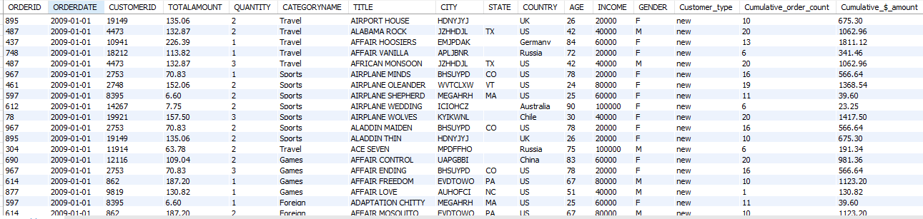

1. By using the report created above, please create summary tables to answer the following questions?
   1. What percent of the sales come from new vs. existing customers?

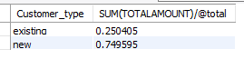

* 1. What is the distribution of sales by category?

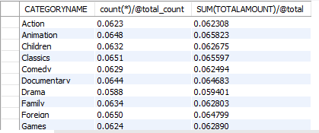

* 1. What is the monthly revenue and what is the cumulative revenue as of each month within a year (cumulative revenue resets at the beginning of each year)?

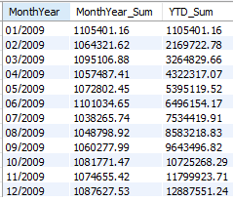

* 1. What is the distribution of sales by customer age buckets?

